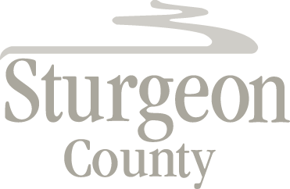

Agenda Item: E.1

Regular Council Meeting: November 26, 2019

Mayor Hnatiw - Motion Re: Council Code of Conduct Bylaw Amendment

Motion: That Council direct Administration to prepare amendments to Bylaw 1404/18, the Council Code of Conduct Bylaw, that include municipal best practices, with the amendments to be presented to Council no later than the February 11, 2020 Council meeting.

Background:
Mayor Hnatiw submitted the above Motion to Legislative Services on October 31, 2019, in accordance with section 82 of Bylaw 1301/13, a Bylaw of Sturgeon County to Regulate the Proceedings of Council and Its Committees.

