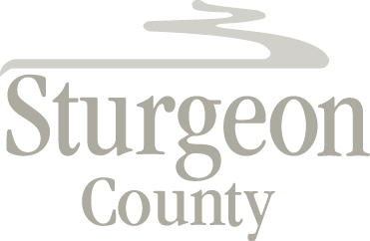

Agenda Item: D.9

Regular Council Meeting: November 12, 2019

CLOSED SESSION – Personnel Matter (Verbal Update)

***Closed session pursuant to section 197(2) of the Municipal Government Act and in accordance with section 17 (disclosure harmful to personal privacy) and section 24 (advice from officials) of the Freedom of Information and Protection of Privacy Act***

