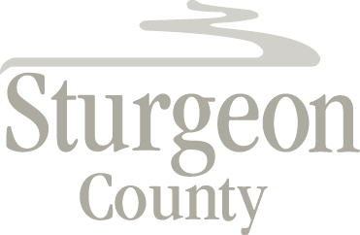

Agenda Item: D.20

Council Meeting: March 23, 2021

Item: CLOSED SESSION – Chief Administrative Officer 2020 Performance Evaluation

***Closed session pursuant to section 197(2) of the Municipal Government Act and in accordance with section 17 (disclosure harmful to personal privacy) of the Freedom of Information and Protection of Privacy Act***

***Materials will be provided at the meeting***

