Case Files and DMP Recommended Culvert Replacement Summary
- Summary of Unfunded Drainage Case Files
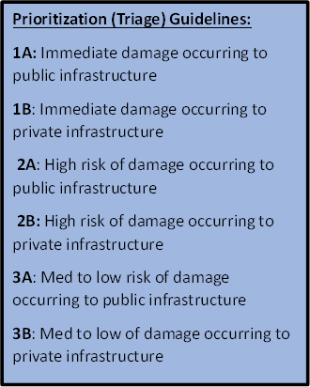
- Drainage Master Plan Recommended Culvert Replacements

