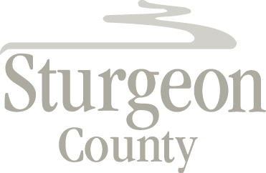

Agenda Item: D.17

Regular Council meeting: December 14, 2021

Item: CLOSED SESSION –Business Development Opportunity

***Closed session pursuant to section 197(2) of the Municipal Government Act and in accordance with section 24 (advice from officials) and section 25 (disclosure harmful to economic and other interests of a public body) of the Freedom of Information and Protection of Privacy Act***

