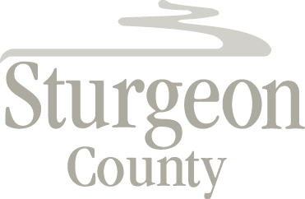

Agenda Item: D.7

Regular Council Meeting: November 26, 2019

Closed Session - Unsightly Property Investigation

***Closed session pursuant to section 197(2) of the Municipal Government Act and in accordance with section 24 (advice from officials) and section 27 (privileged information) of the Freedom of Information and Protection of Privacy Act***

