2021 Mid-year Management Report
Attachment 2
Prepared by Corporate Planning and Intergovernmental Services | Current as of July 2021

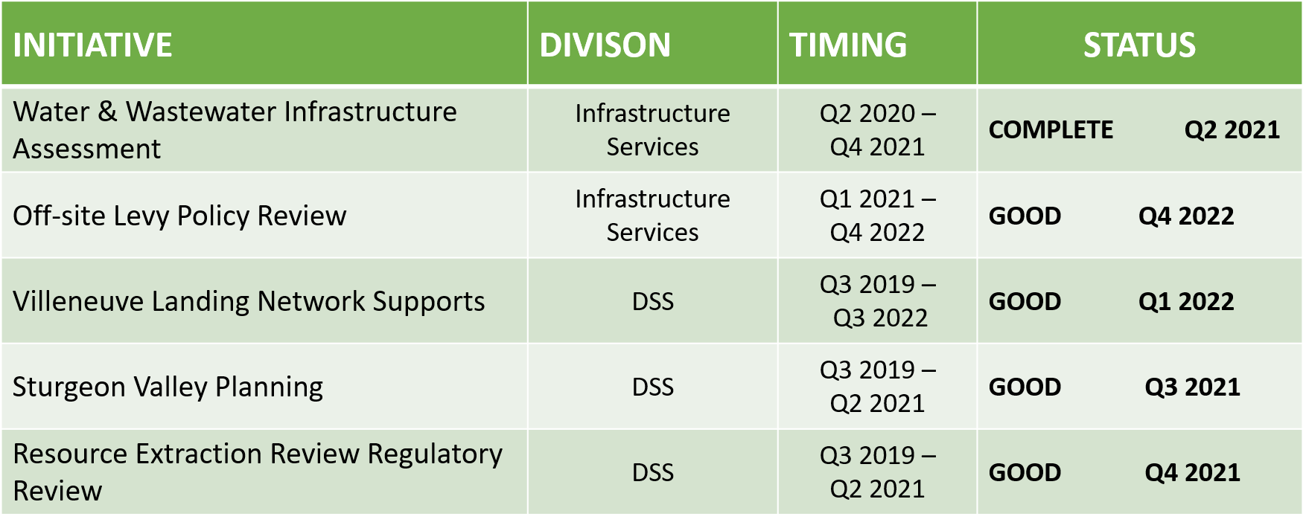
Planned Growth and Prosperity

Maintain and Enhance Strong Communities
VE
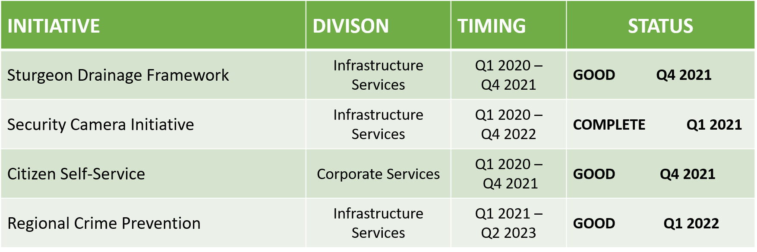

Strong Local and Regional Governance
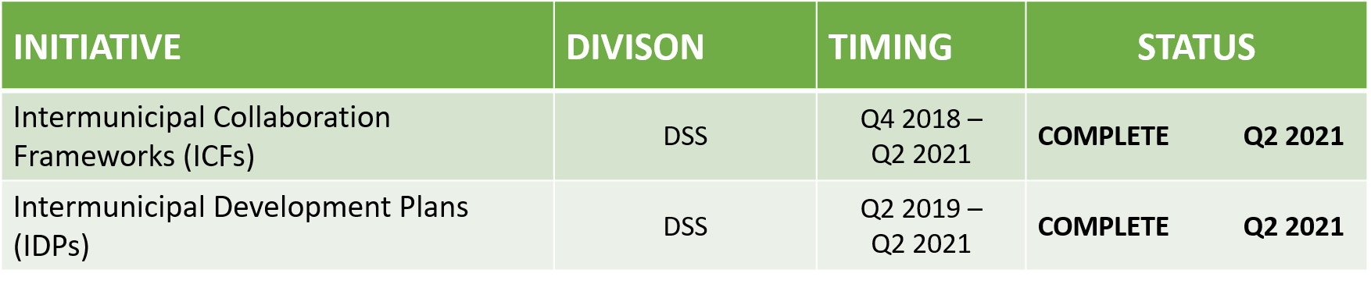

Good
Complete
Some Risk
Serious Risk

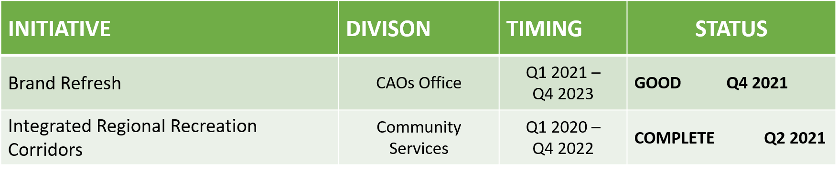
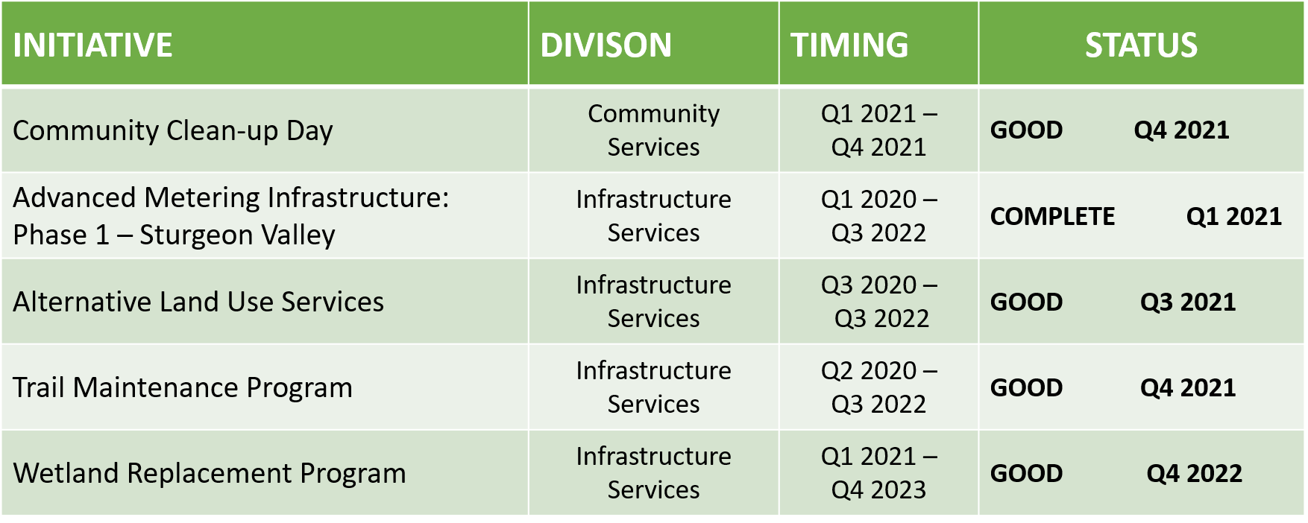
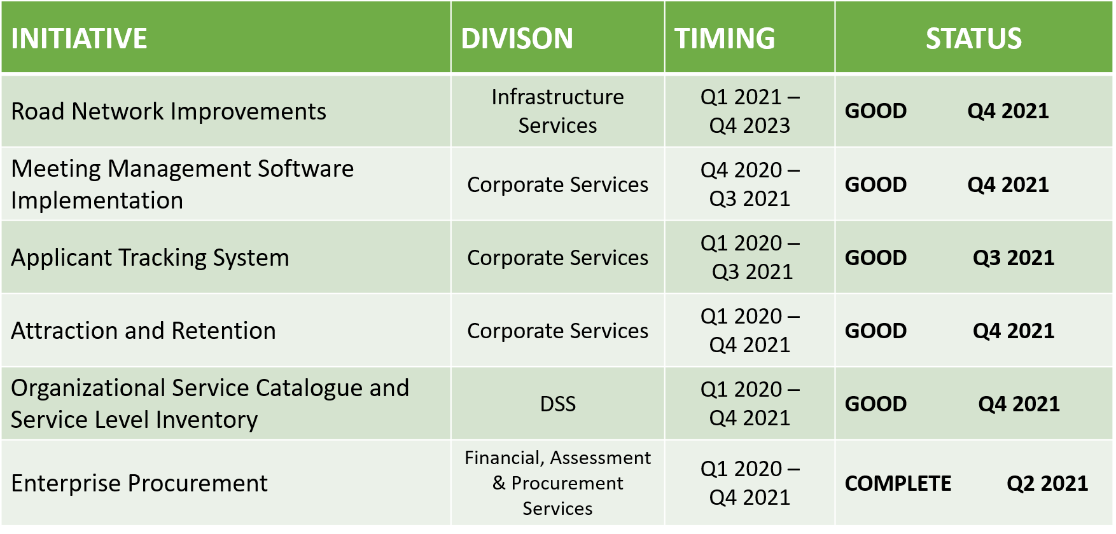
Community Identity and Spirit
VE
Environmental Stewardship
Operational Excellence

VE

Good
Complete
Some Risk
Serious Risk

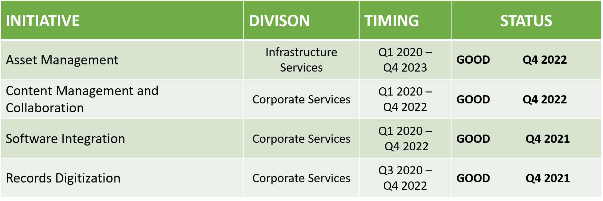
Operational Excellence (CONT.)
Good
Complete
Some Risk
Serious Risk

