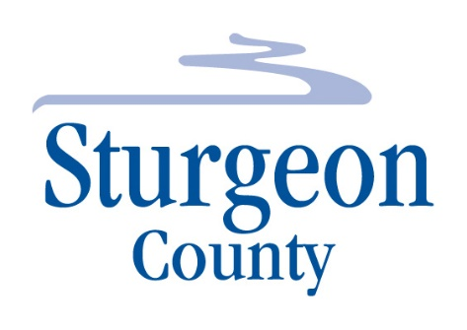
Agenda Item: D.7

Regular Council Meeting: June 8, 2021

Item: Bylaw 1555/21 - Sturgeon Valley South Area Structure Plan - First Reading

LINK to Sturgeon Valley South Area Structure Plan Appendices
Sturgeon Valley South Area Structure Plan Appendices

