BYLAW 1568/21
AMENDMENT TO LAND USE BYLAW 1385/17
STURGEON COUNTY, MORINVILLE, ALBERTA

A BYLAW OF STURGEON COUNTY, MORINVILLE, ALBERTA FOR THE PURPOSE OF AMENDING LAND USE BYLAW 1385/17.

WHEREAS, the Municipal Government Act, RSA 2000 c M-26, any regulations thereunder, and any amendments or successor legislation thereto, authorize Council to establish and amend the Land Use Bylaw 1385/17;

AND WHEREAS, the Council of Sturgeon County has deemed it desirable to amend Land Use Bylaw 1385/17;

NOW THEREFORE, the Council of Sturgeon County, in the Province of Alberta, duly assembled, enacts as follows:

- Title
  - This Bylaw may be referred to as the “Agriculture to Recreational Vehicle Storage Redistricting - 2021”.

- Purpose
  - The purpose of this Bylaw is to redesignate the land use district of the parcel subject to this Bylaw.

- Application
  - Land Use Bylaw 1385/17 is amended as follows:

    - That Block B, Plan 1484NY, as shown on Schedule “A”, is redistricted from “AG – Agriculture District” to “RVS – Recreational Vehicle Storage”.

    - That Part 19.2 Schedule 1 – Land Use District Map is changed to reflect the redistricting for the lands located within NE-7-54-24-4 / Block B, Plan 1484NY, as shown in Schedule “A”.

- Severability
  - If any portion of this Bylaw is declared invalid by a court of competent jurisdiction, then the invalid portion must be severed and the remainder of the Bylaw is deemed valid.

- Effective Date
  - This Bylaw shall come into force upon being passed.

Read a first time this 9th day of November, 2021.

Read a second time this ___ day of _______ 20___.

Read a third time this ___ day of ________ 20___.

Alanna Hnatiw
MAYOR

Reegan McCullough
COUNTY COMMISSIONER

_____________________
DATE SIGNED

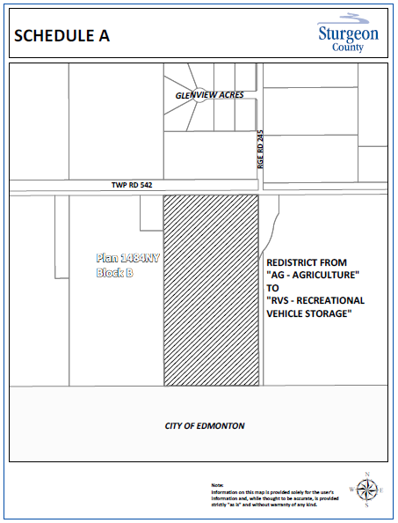
Schedule “A”

