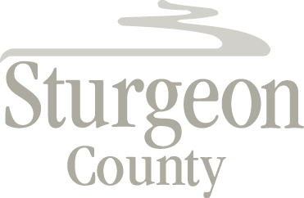

Agenda Item: D.5

Regular Council Meeting: October 27, 2020

Item: CLOSED SESSION - Contractual Matter

***Closed session pursuant to section 197(2) of the Municipal Government Act and in accordance with section 24 (advice from officials), section 25 (disclosure harmful to economic and other interests of a public body) and section 27 (privileged information) of the Freedom of Information and Protection of Privacy Act***

