BYLAW 1461/19
AMENDMENTS TO LAND USE BYLAW 1385/17
DC1, RECREATIONAL VEHICLE STORAGE AND R6 - MODULAR DWELLING DISTRICT
STURGEON COUNTY, MORINVILLE, ALBERTA

A BYLAW OF STURGEON COUNTY, ALBERTA FOR THE PURPOSE OF AMENDING THE LAND USE BYLAW 1385/17.

WHEREAS, the Municipal Government Act, RSA 2000 c.M-26, any regulations thereunder, and any amendments or successor legislation thereto, authorize Council to establish and amend the Land Use Bylaw 1385/17;

AND WHEREAS, the Council of Sturgeon has deemed it desirable to amend Land Use Bylaw 1385/17;

NOW THEREFORE, the Council of Sturgeon County, duly assembled, hereby enacts as follows:

THAT LAND USE BYLAW 1385/17 BE AMENDED AS FOLLOWS:

- That the following parcels, i.e.:
Pt. SE 31-54-27 W4M;
Lot 54, Block RLY, Plan 6054AO; and,
Lot D, Plan 2436NY,
as shown in Schedule “A”, be re-districted from “DC1 – Direct Control District” to “R6 – Modular Dwelling District”.
- That Part 19.2 Schedule 1 – Land Use District Map be changed to reflect the re-districting of
Pt. SE 31-54-27 W4M;
Lot 54, Block RLY, Plan 6054AO; and,
Lot D, Plan 2436NY,
as shown in Schedule “A”.
- That a ±2.2ha portion and a 1.04ha portion of SE 31-55-25 W4M, as shown in Schedule “B”, be re-districted respectively from DC1 – Direct Control District” and “AG – Agricultural District” to “RVS – Recreational Vehicle Storage District”.
- That Part 19.2 Schedule 1 – Land Use District Map be changed to reflect the re-districting of a ±2.2ha portion and a 1.04ha portion of SE 31-55-25 W4M, as shown in Schedule “B”.
- That a ±3.29ha portion of Lot 1, Block 4, Plan 0426720, as shown in Schedule “C”, be re-districted from “DC1 – Direct Control District” to “RVS – Recreational Vehicle Storage District” and the remaining ±1.2ha portion of the parcel and as shown in Schedule “C”, be re-districted from “DC1 – Direct Control District” to “R2 – Country Estate Residential District”.
- That Part 19.2 Schedule 1 – Land Use District Map be changed to reflect the re-districting of Lot 1, Block 4, Plan 0426720, as shown on Schedule “C”.
- That a ±3.01ha portion of SE 14-55-26 W4M, as shown on Schedule “D”, be re-districted from “AG – Agriculture District” to “RVS – Recreational Vehicle Storage District”.
- That Part 19.2 Schedule 1 – Land Use District Map be changed to reflect the re-districting of a ±3.01ha portion of SE 14-55-26 W4M as shown on Schedule “D”.
- That a ±1.35ha portion of Lot 2, Block 1, Plan 2020457, as shown in Schedule “E”, be re-districted from “AG – Agricultural District” to “DC1 – Direct Control District”.
- That Part 19.2 Schedule 1 – Land Use District Map be changed to reflect the re-districting of Lot 2, Block 1, Plan 2020457, as shown on Schedule “E”.
- That Land Use Bylaw 1385/17 be amended by adding the following district “DC 14– Direct Control District 14 – Lot 11, St. Albert Settlement” as described in Schedule “F”.
- That Lot 11, St. Albert Settlement be re-districted from “DC1 – Direct Control District” to “DC14 – Direct Control District 14 – Lot 11, St. Albert Settlement”.
- That Part 19.2 Schedule 1 – Land Use District Map be changed to reflect the re-districting of Lot OT, St. Albert Settlement to “DC14 – Direct Control District 14 – Lot 11 St. Albert Settlement”.
- That Land Use Bylaw 1385/17 be amended by adding the following district “DC 19– Direct Control District 19 – Lot 1, Plan 9022530” as described in Schedule “G”.
- That Lot 1, Plan 9022530 and a ±1ha portion of Lot 1, Block 1, Plan 0423964 as indicated in Schedule “H” be re-districted from “DC1 – Direct Control District” to “DC19 – Direct Control District 19 – Lot 1, Plan 9022530”.
- That Part 19.2 Schedule 1 – Land Use District Map be changed to reflect the re-districting of Lot 1, Plan 9022530 and a ±1ha portion of Lot 1, Block 1, Plan 0423964 as indicated in Schedule “H”.
- That a ±8ha portion of Lot 1, Block 1, Plan 1222385 as indicated in Schedule “I” be re-districted from AG – Agriculture District” to “DC1 – Direct Control District”.
- That Part 19.2 Schedule 1 – Land Use District Map be changed to reflect the re-districting of a ±8ha portion of Lot 1, Block 1, Plan 1222385 as indicated in Schedule “I”.

This Bylaw shall come into force and take effect upon being passed.

Read a first time this 26th day of May, 2020.

Read a second time this ___ day of _______ 2020.

Read a third time this ___ day of ________ 2020.

Alanna Hnatiw
MAYOR

Reegan McCullough
COUNTY COMMISSIONER (CAO)

DATE SIGNED

Schedule “A”
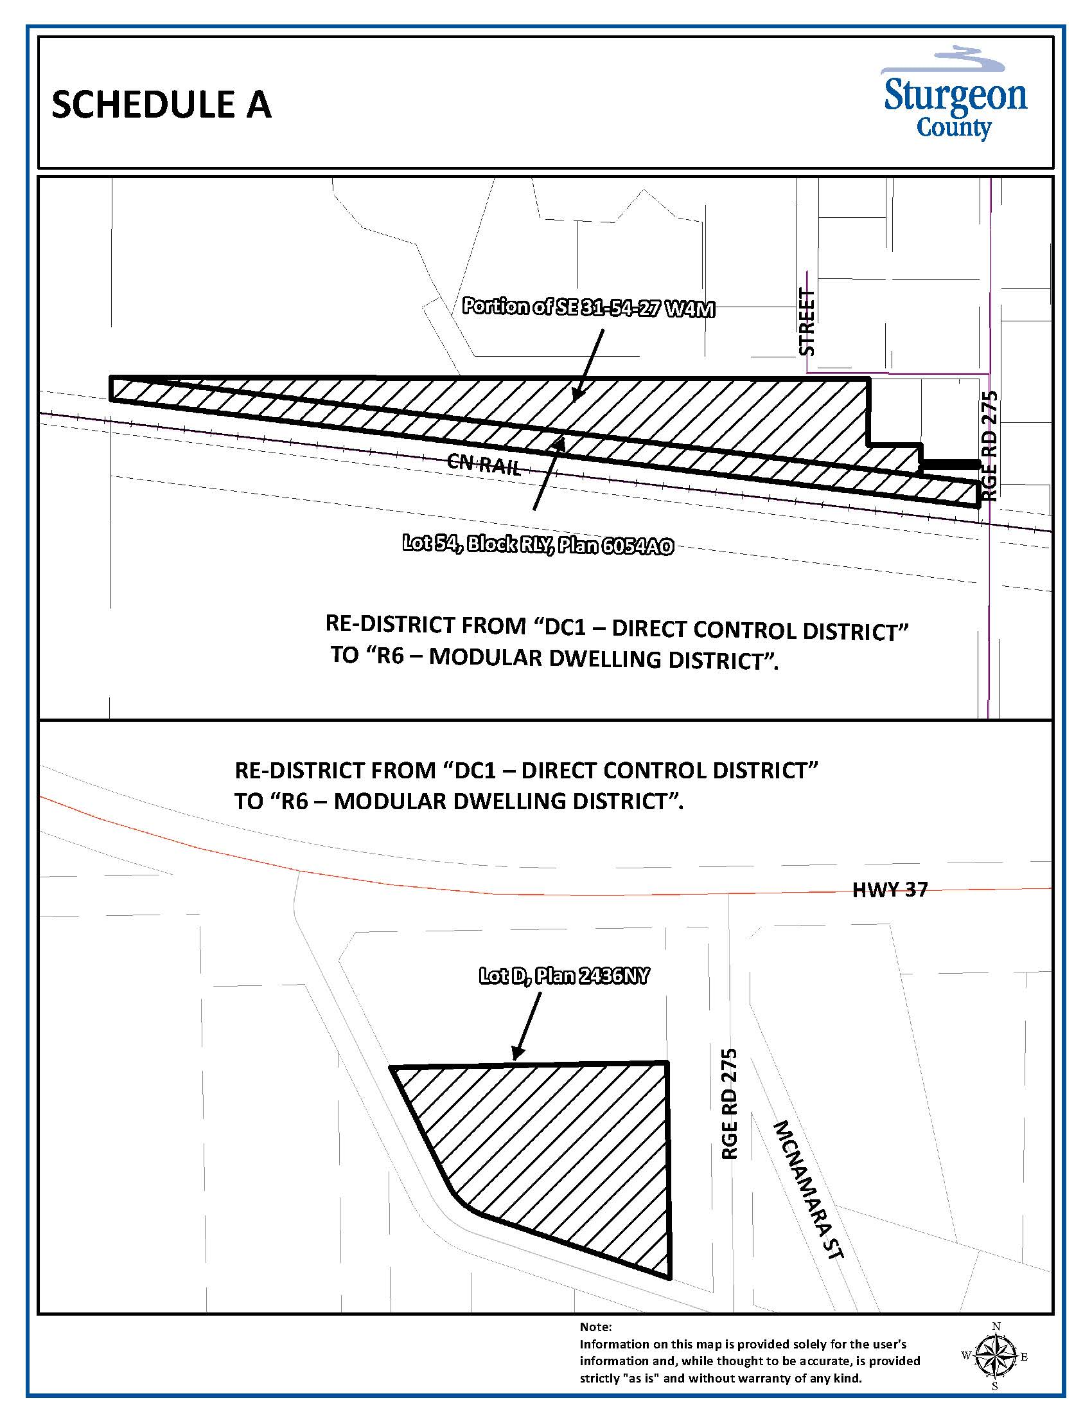
Schedule “B”

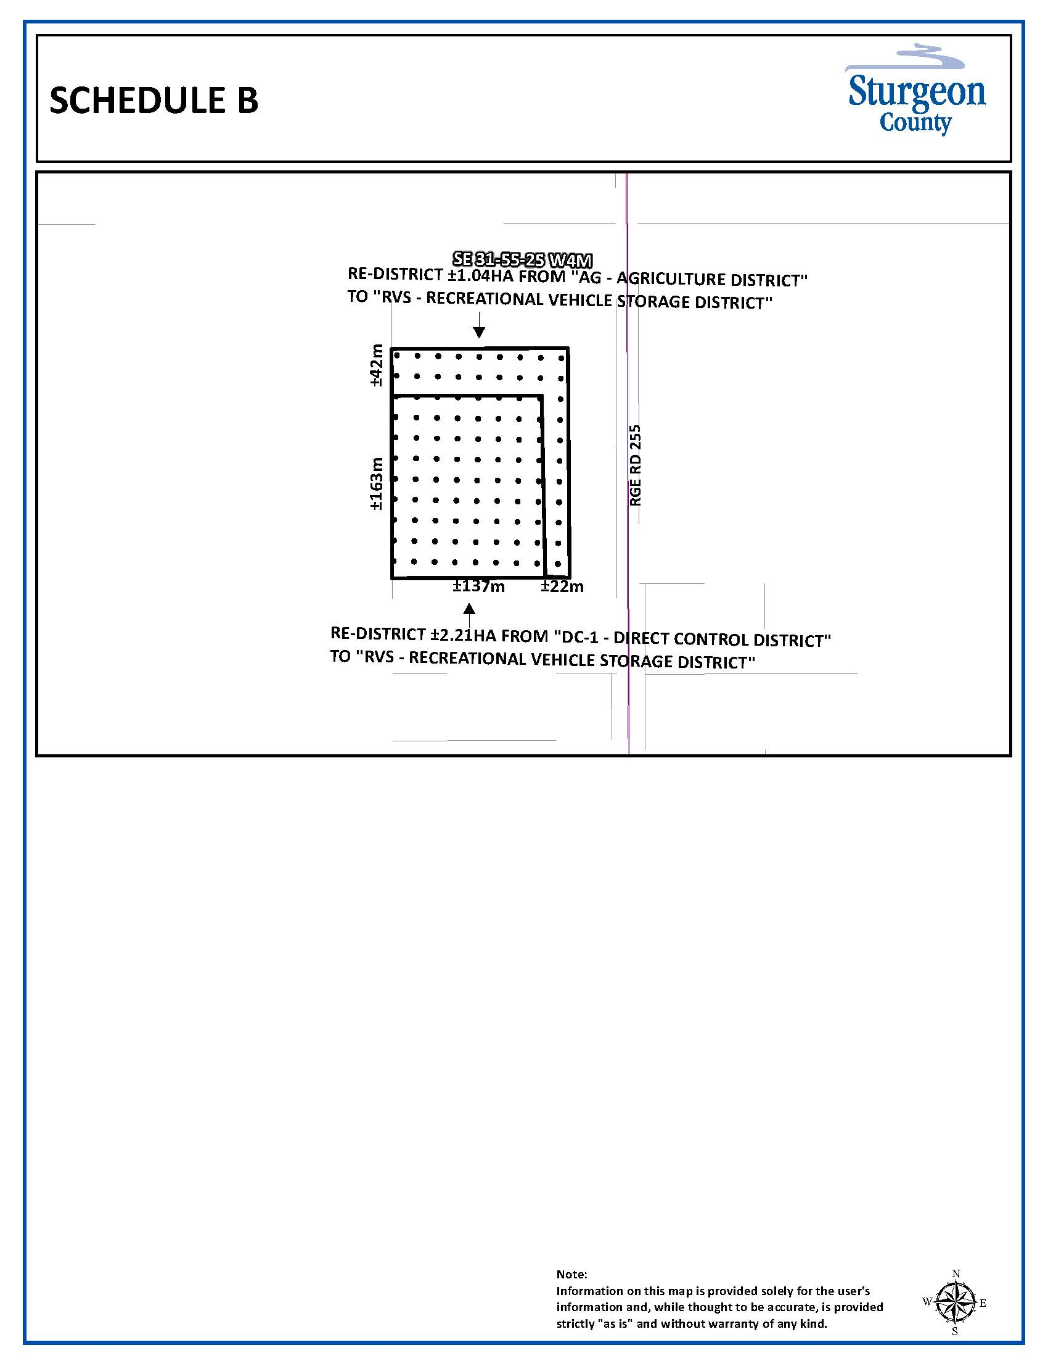
Schedule “C”
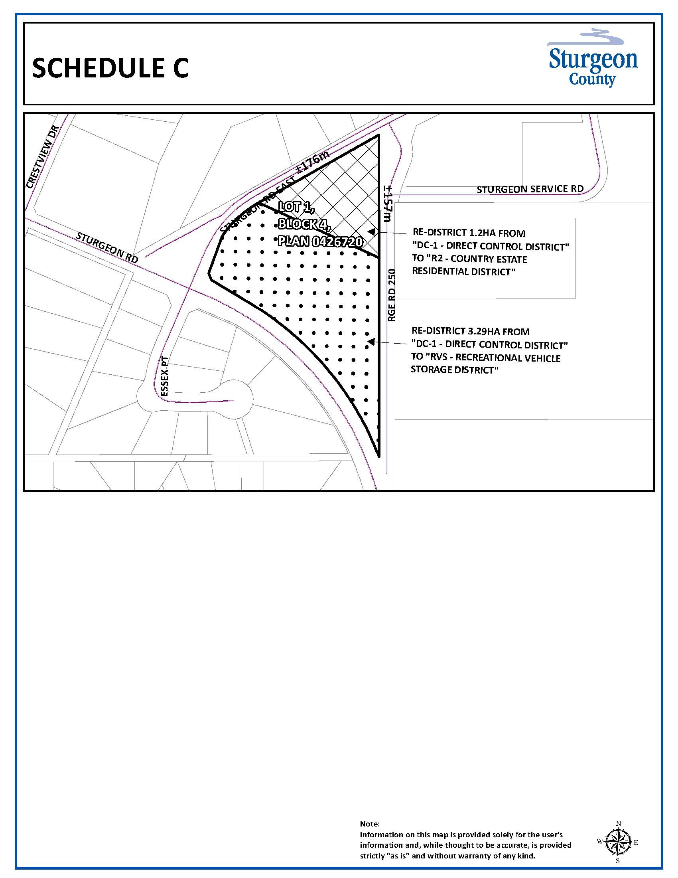
Schedule “D”

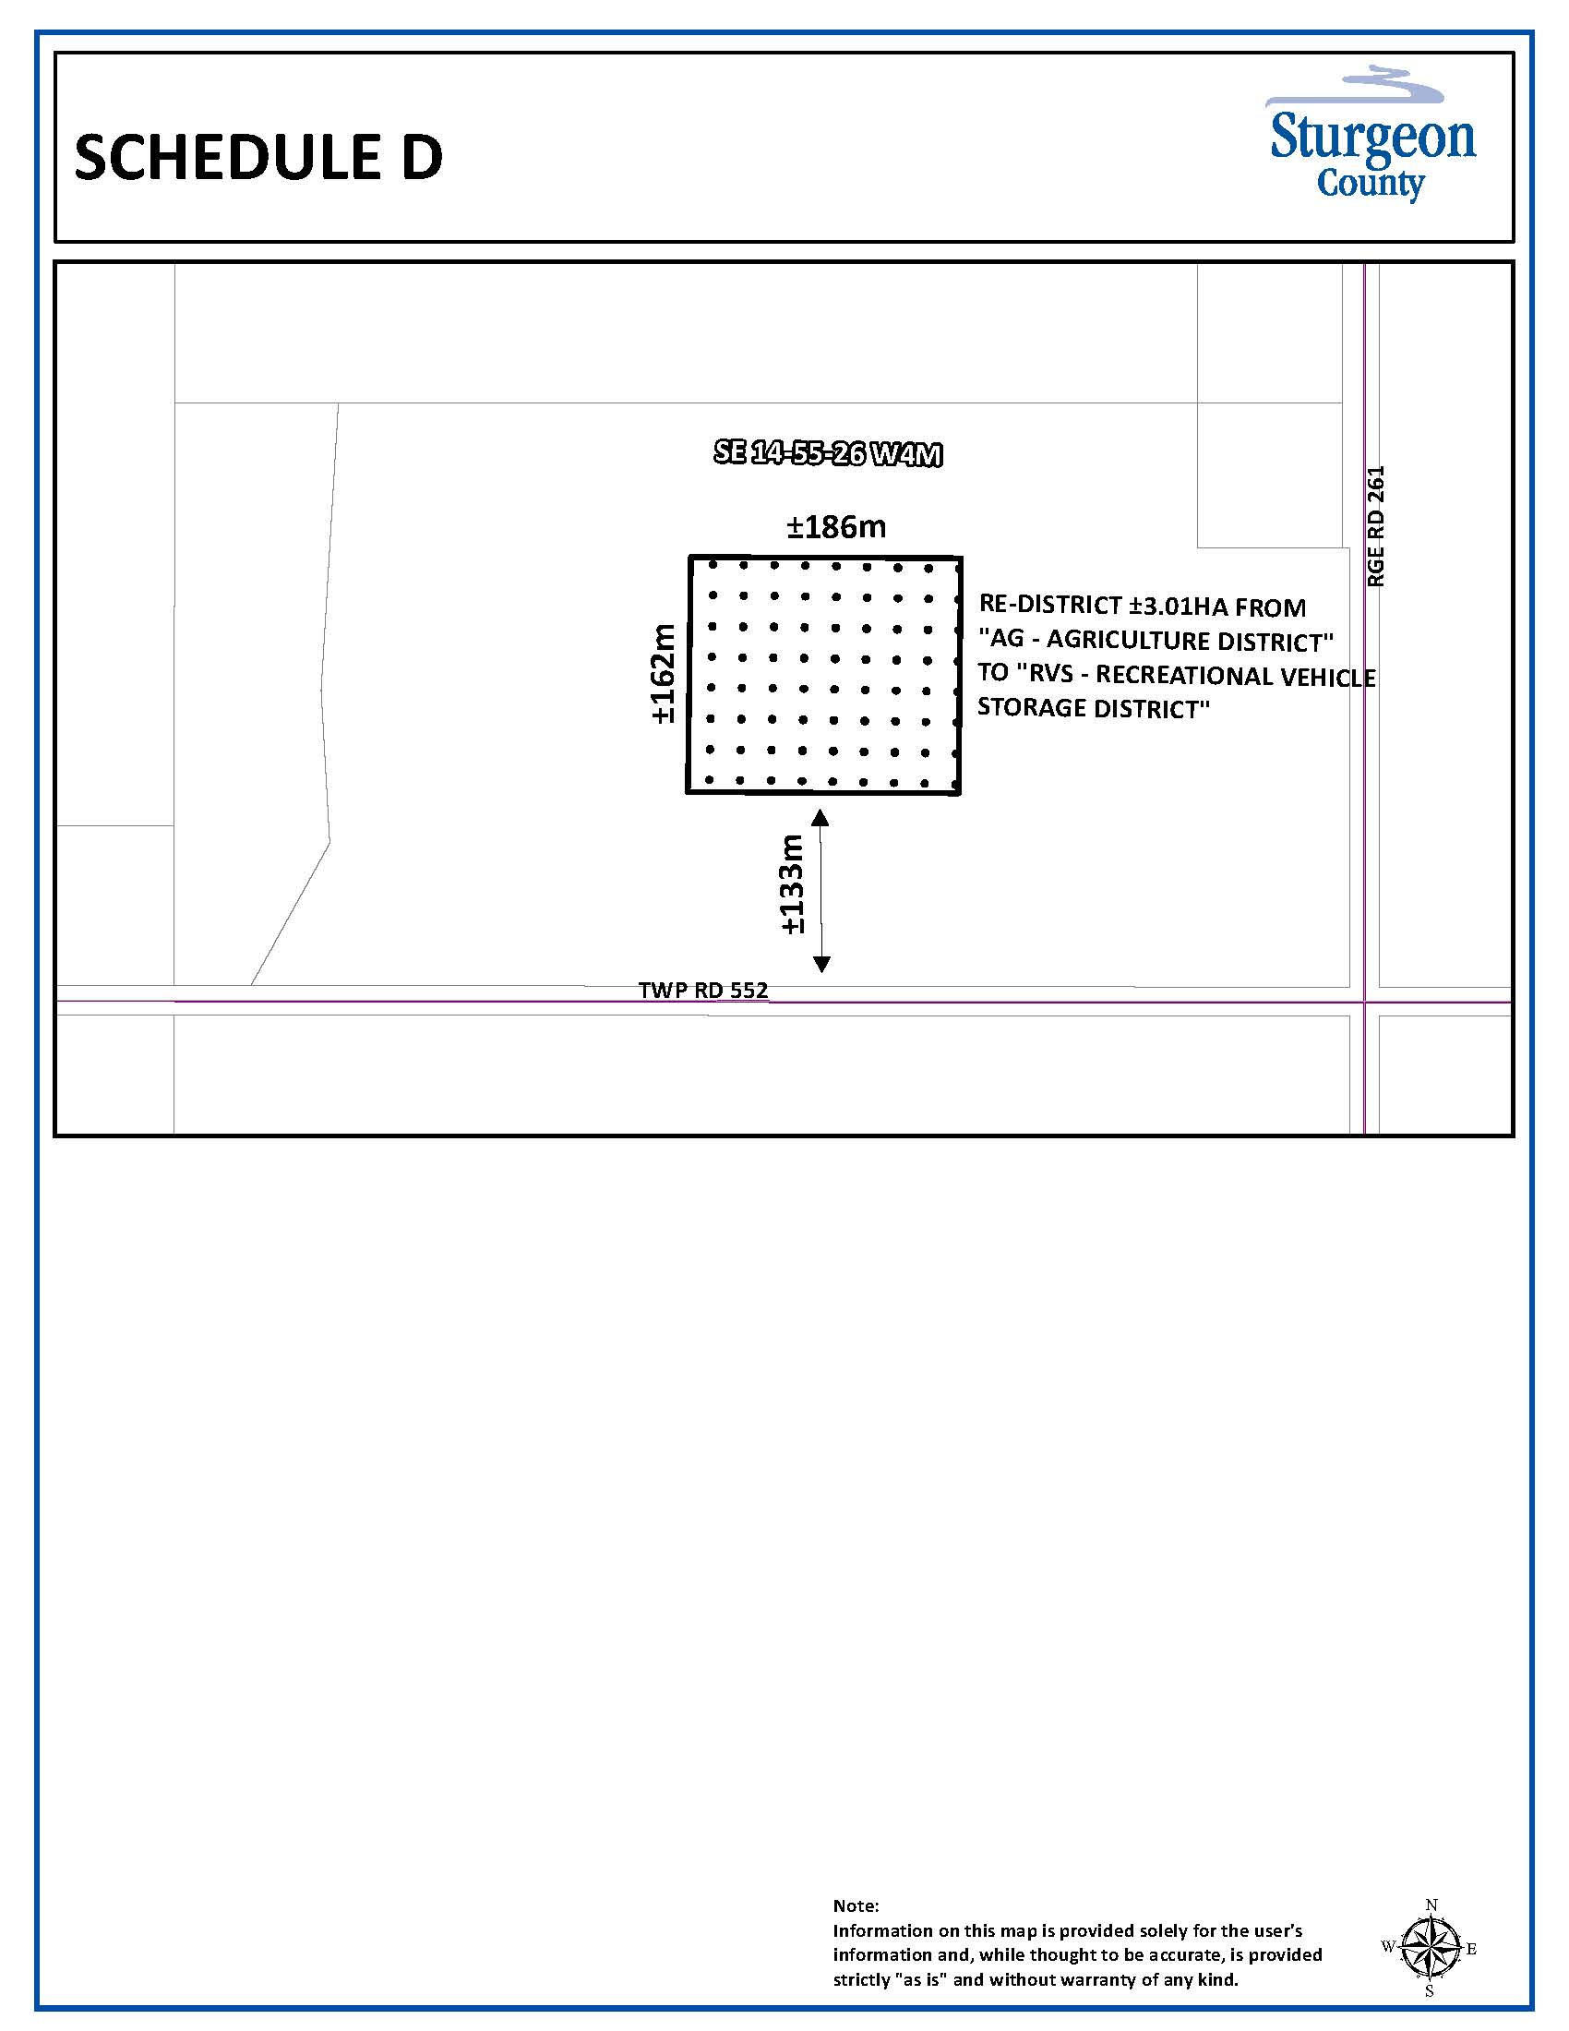
Schedule “E”
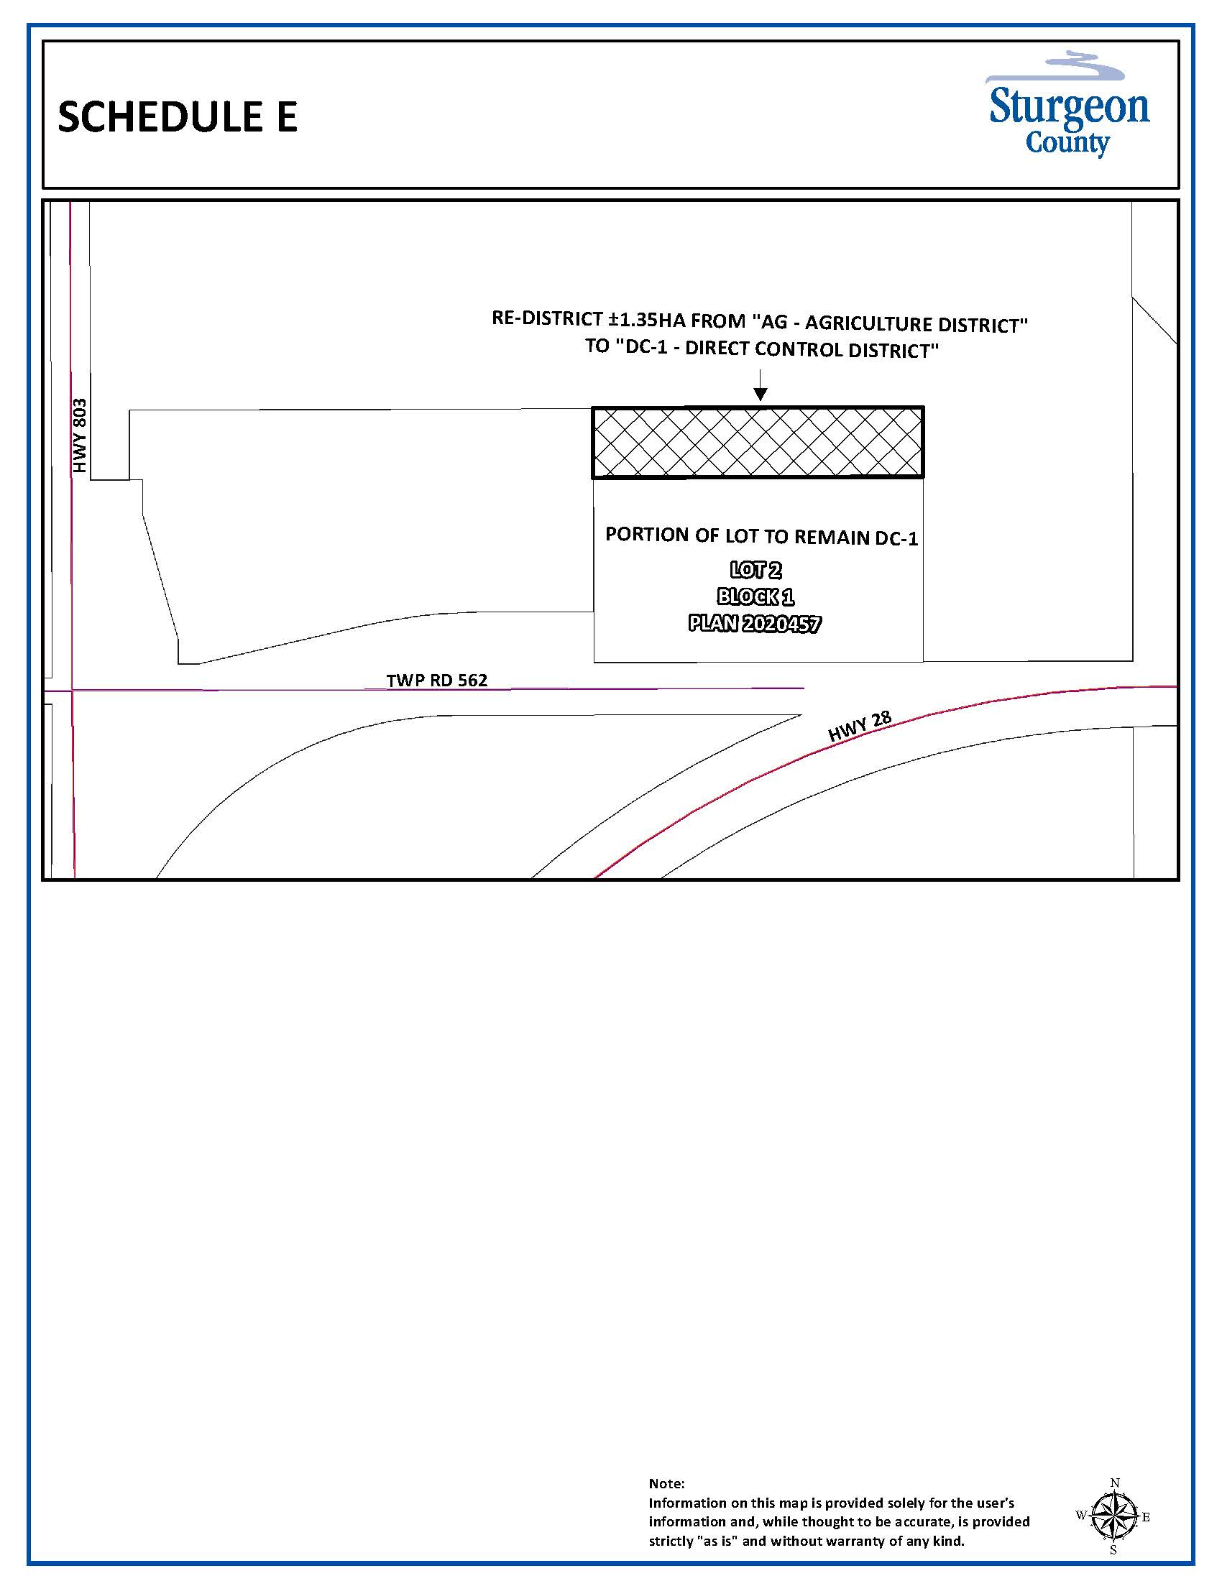
Schedule “F”


16.14 DC14 – Direct Control District 14 – Lot OT, St. Albert

Settlement
    - General Purpose
To establish a Direct Control District that provides for the limited recreational/industrial use provided for herein, and the existing Fleet service business located on the property.
    - District Boundaries
Lot OT, St. Albert Settlement.
    - Decision-Making Authority
In this district, the Decision-Making Authority is the Development Officer and the Municipal Planning Commission.
    - Uses
Development Officer | Municipal Planning Commission
Accessory, building | Accessory, building
Accessory, use | Accessory, use
Dwelling, single detached | Campground
Fleet service | Outdoor Storage

    - Subdivision Regulations
Any future subdivision of the subject property will be at the discretion of the Subdivision Authority and may require an amendment to this Bylaw.
    - Development Regulations
All yard setbacks and heights | At the discretion of the Development Authority
Parcel coverage | At the discretion of the Development Authority

    - Additional Development Regulations
All development in this district is subject to the regulations stated in Parts 5 through 9 of this Bylaw.

Schedule “G”

16.19 DC19 – Direct Control District 18 – Lot 1, PLAN 9022530

    - General Purpose
To establish a Direct Control District that provides for limited recreational vehicle storage and recreation.

    - District Boundaries
Lot 1, Plan 9022530 and a ±1ha portion of Lot 1, Block 1, Plan 0423964.
    - Decision-Making Authority
In this district, the Decision-Making Authority is the Development Officer and the Municipal Planning Commission.
    - Uses
Development Officer | Municipal Planning Commission
Accessory, building | Accessory, building
Accessory, use | Accessory, use
Dwelling, single detached | Campground
Dugout | Eating and Drinking Establishment
Recreational Vehicle Storage Facility | Recreation facility, outdoor

    - Subdivision Regulations
Any future subdivision of the subject property will be at the discretion of the Subdivision Authority.
    - Development Regulations
All yard setbacks and heights | At the discretion of the Development Authority
Parcel coverage | At the discretion of the Development Authority

    - Additional Development Regulations
      - All development in this district is subject to the regulations stated in Parts 5 through 9 of this Bylaw.
      - Notwithstanding subsection 16.18.4 the number of dwelling units on a parcel must conform to Section 5.5 of this Bylaw.
      - The number and location of shipping containers shall be at the discretion of the Development Authority.

Schedule “H”
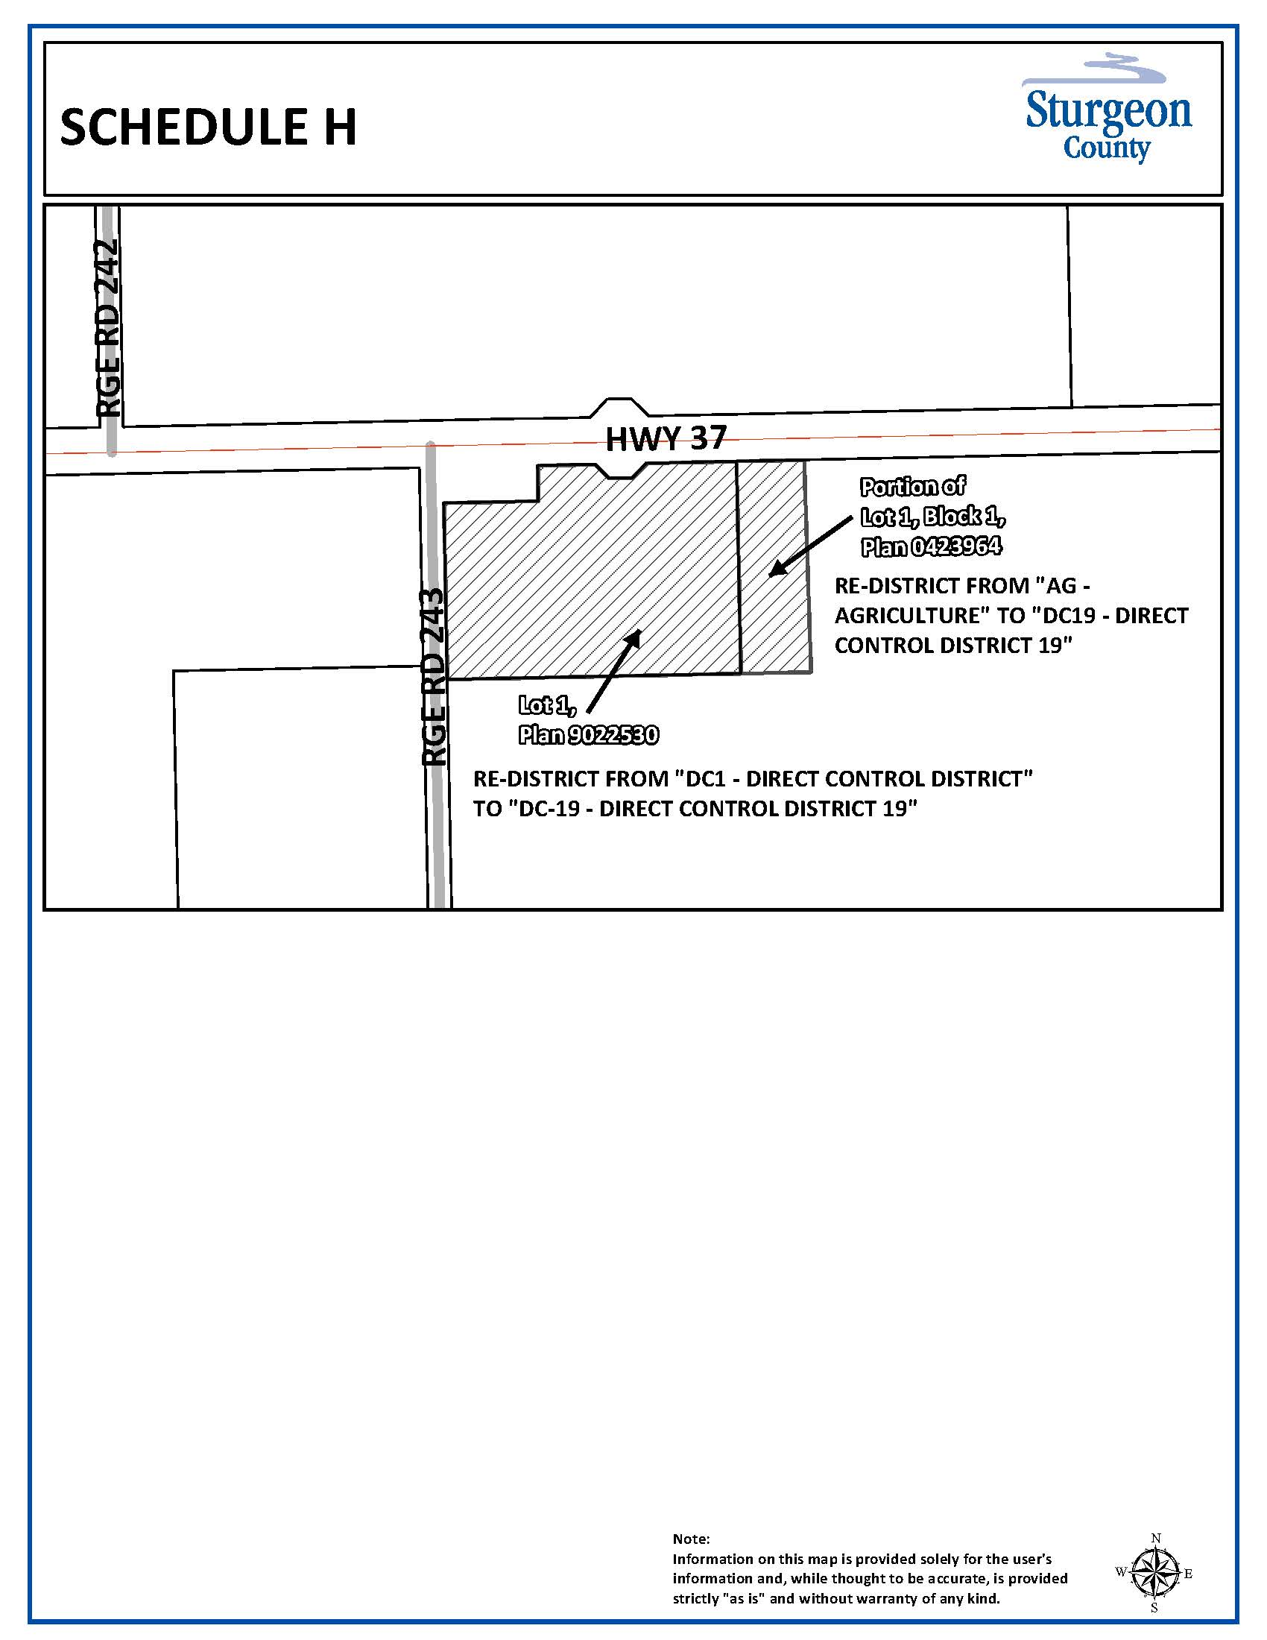

Schedule “I”

