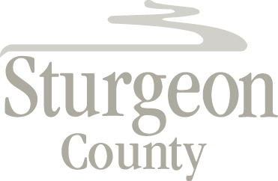

Agenda Item: D.9

Council Meeting: April 28, 2020

Item: CLOSED SESSION - Alberta Industrial Heartland Association Policy

***Closed session pursuant to section 197(2) of the Municipal Government Act and in accordance with section 24 (advice from officials) and section 25 (disclosure harmful to economic or other interests of a public body) of the Freedom of Information and Protection of Privacy Act***

