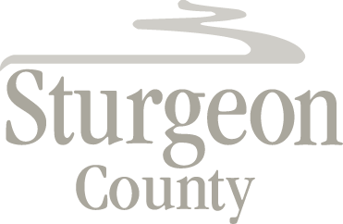

Regular Council Meeting: April 11, 2017
Agenda Item: Item C.1.1

9:00 a.m. - NWR Contribution Acknowledgement

