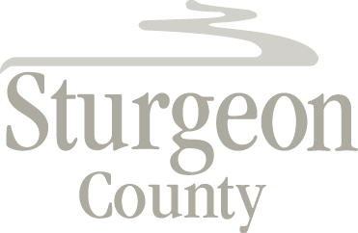

Agenda Item: D.7

Regular Council Meeting: November 12, 2019

CLOSED SESSION - Crossing at River’s Edge - Emergency Access Feasibility Study

***Closed session pursuant to section 197(2) of the Municipal Government Act and in accordance with section 24 (advice from officials) of the Freedom of Information and Protection of Privacy Act***

