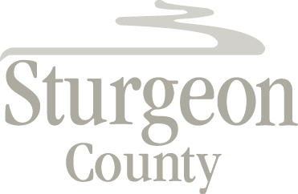

Agenda Item: D.11

Council Meeting: June 16, 2020

Item: CLOSED SESSION - Land Use Compliance and Community Input

***Closed session pursuant to section 197(2) of the Municipal Government Act and in accordance with section 24 (advice from officials) of the Freedom of Information and Protection of Privacy Act***

