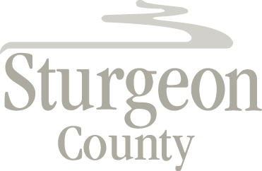

Agenda Item: D.7

Regular Council meeting: August 24, 2021

Item: CLOSED SESSION – Economic Development Opportunity

***Closed session pursuant to section 197(2) of the Municipal Government Act and in accordance with section 24 (advice from officials) and section 25 (disclosure harmful to economic and other interests of a public body) of the Freedom of Information and Protection of Privacy Act***

