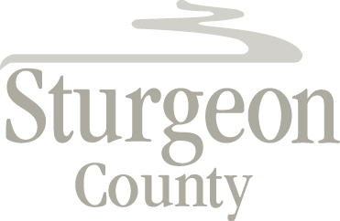

Agenda Item: D.19

Regular Council Meeting: March 23, 2021

Item: CLOSED SESSION – River Valley Alliance Community Engagement Committee - Appointment of Public Members

***Closed session pursuant to section 197(2) of the Municipal Government Act and in accordance with in accordance with section 17 (disclosure harmful to personal privacy) of the Freedom of Information and Protection of Privacy Act***

