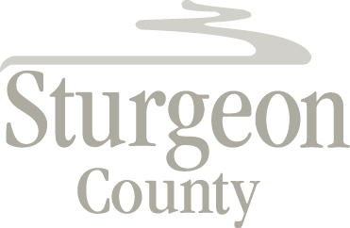

Agenda Item: D.9

Regular Council Meeting: June 16, 2020

Item: CLOSED SESSION – St. Albert Annexation Negotiations

***Closed session pursuant to section 197(2) of the Municipal Government Act and in accordance with section 24 (advice from officials) and section 25 (disclosure harmful to economic and other interests of a public body) of the Freedom of Information and Protection of Privacy Act***

