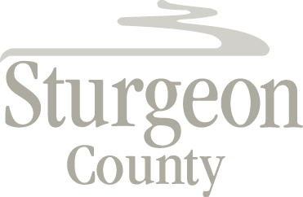

Agenda Item: D.10

Regular Council Meeting: October 22, 2019

Item: 1:00 p.m. CLOSED SESSION – Investigation Update

A verbal update will be provided at the Council meeting.

***Closed Session pursuant to section 197(2) of the Municipal Government Act and in accordance with section 17 (disclosure harmful to personal privacy) and section 24 (advice from officials) of the Freedom of Information and Protection of Privacy Act***

