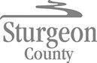

Agenda Item: D.6

Request for Decision

Title | 2021 Gravel Road Stabilization Contract Award
Proposed Motion | - That Council award the contract for Type “A”, “B” and “D” of the 2021 Gravel Road Stabilization program to PME Inc. at a contract price of $1,800,575.04 (excluding GST) and authorize the Chief Administrative Officer to execute the contract.  - That Council award the contract for Type “C” of the 2021 Gravel Road Stabilization program to Doblanko Contracting Ltd. at a contract price of $52,320 (excluding GST) and authorize the Chief Administrative Officer to execute the contract.
Administrative  Recommendation | Administration recommends that Council award the contract for Type “A”, “B”, and “D” of the 2021 Gravel Road Stabilization program to PME Inc. as the lowest compliant bidder, and that Council award the contract for Type “C” of the 2021 Gravel Road Stabilization program to Doblanko Contracting Ltd. as the lowest compliant bidder.
Previous Council Direction | December 8, 2020 Regular Council Meeting  Motion 579/20: That Council approve the 2021 Operating and Capital Budget as amended by motions passed on November 27, 2020 and represented by a 0% tax rate increase with $8,932,886 Significant Tax Revenue Growth allocated to the policy priority reserves for Council’s consideration in early 2021.
Report | Background Information  The 2021 Gravel Road Stabilization program is comprised of the following projects:  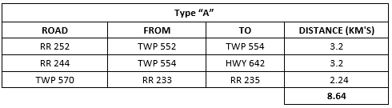  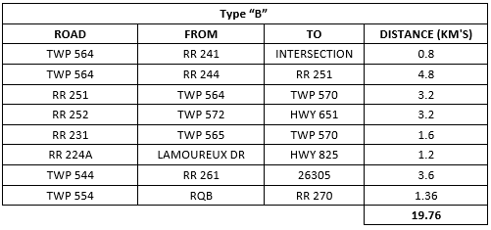  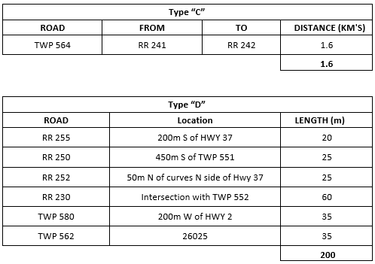  External Communication  Tendering  - The construction Request for Tender (RFT) for the 2021 Gravel Road Stabilization Program was posted on Alberta Purchasing Connection (APC) on April 26, 2021, with a closing date of May 19, 2021.  - Three (3) bids were received for the four (4) categories of work tendered  TYPE “A” TYPE “B” TYPE “C” TYPE “D”  $544,607.40 - $770,637.00 $1,079,900.99 - $1,150,138.85 $52,320.00 - $104,800.00 $176,066.65 - $253,523.75  The received tenders were reviewed, and it is recommended that Sturgeon County award the 2021 Gravel Road Stabilization contract for category Types “A”, “B”, and “D” to PME Inc., and for category Type “C” to Doblanko Contracting Ltd. as they were the lowest compliant bidders in respective categories.  Communications  - Following the contract award and prior to commencement of construction:  - Notifications will be mailed to all affected residents.  - Construction information signs will be installed.  - A construction open house will be held.  Relevant Policy/Legislation/Practices:  Procurement Policy  - Invitation to Tender is identified as the acceptable method of procurement for construction contracts and other high value procurements.  - Sturgeon County’s standard for communicating competitive Procurement opportunities is through the Alberta Purchasing Connection.  - The Chief Administrative Officer is designated with approval authority for procurement $500,000 and in excess thereof.
Implication of Administrative Recommendation | Strategic Alignment:  - Maintain and Enhance Strong Communities – The award of these contracts is consistent with Goal 2.2 of the Strategic Plan: “Sturgeon County Residents have access to safe and reliable infrastructure assets”.  - Strong Local and Regional Governance – The award of these contracts is consistent with Goal 3.2 of the Strategic Plan: “Sturgeon County is financially stable and fiscally sustainable”.  Organizational:  - The award of these contracts will significantly reduce the maintenance requirements of these road segments and address ongoing traffic issues, thereby freeing up additional capacity to maintain Sturgeon County’s service commitment to operational excellence.  Financial:  Estimated Costs  Type “A” $544,607.40  Type “B” $1,079,900.99  Type “C” $52,320.00  Type “D” $176,066.65  Total Funding Requirement $1,852,895.04  Budget  LRP Stabilization / Selective Grading $1,500,000.00  Gravel Road Stabilization (Operations) $576,000.00  Shoulder Stabilization (Operations) $265,000.00  Total Available Funds $2,341,000.00
Alternatives Considered | - Council could decide not to award the contracts at this time.
Implications of Alternatives | Strategic Alignment:  - Maintain and Enhance Strong Communities – Not awarding the contracts would be inconsistent with Goal 2.2 of the Strategic Plan: “Sturgeon County residents have access to safe and reliable infrastructure assets”.  - Strong Local and Regional Governance – Not awarding the contract would be inconsistent with Goal 3.2 of the Strategic Plan: “Sturgeon County is financially stable and fiscally sustainable”.  Sub-goal 3.2.3 states that Sturgeon County is to have “[a] level of infrastructure provided that is affordable, safe and sustainable as set by long-range plans”. Should this contract not be awarded, Sturgeon County’s overall life-cycle cost of maintaining these assets will increase thus decreasing the affordability. There is also a moderately increased safety risk to the travelling public driving as deteriorated roads can increase collision risk.  Organizational:  - By not awarding the contract, Sturgeon County will be required to continue maintenance on some of the most maintenance intensive road assets, thereby reducing the County’s overall capacity to maintain Sturgeon County’s service commitment to operational excellence.  Financial:  - Not awarding this contract will only temporarily defer the required capital renewal cost for these road assets while the County’s immediate maintenance costs will continue to grow.
Follow up Action | - Execute the contracts with PME Inc. and Doblanko Contracting Ltd. (CAO Office, Q2 2021).  - Mail notification letters to residents (Transportation and Engineering Services, Q3, 2021).

Attachment(s) | - Attachment 1: Locations Map  - Attachment 2: Tender Bid Results
Report Reviewed by: | Gary Mayhew, Manager, Transportation and Engineering Services  Scott MacDougall, Chief Operations Officer – COO  Reegan McCullough, County Commissioner – CAO

Strategic Alignment Checklist
Vision: Sturgeon County: a diverse, active community that pioneers opportunities and promotes initiative while embracing rural lifestyles.
Mission: Provide quality, cost effective services and infrastructure to meet the diverse needs of the Sturgeon County community, while improving competitiveness and sustainability.

Focus Areas | Not consistent | N/A | Consistent
Planned Growth and Prosperity
We encourage varied and integrated enterprises that enhance our strong economic  base, while balancing the needs of the community and natural environment.  (Strategic Plan and MDP pg. 36) | ☐ | ☒ | ☐
- Supports a strong thriving business environment to strengthen our economic foundation | ☐ | ☒ | ☐
- Plans for responsible growth through the MDP and regional growth plan. | ☐ | ☒ | ☐
- Manages growth for current and future developments through:  - transparent bylaws, policies and processes to enable responsible land development | ☐ | ☒ | ☐
- targeting growth around existing and identified future growth areas | ☐ | ☐ | ☒
Maintain and Enhance Strong Communities
We are committed to a safe and viable community, where our residents are  provided with access to opportunities and quality of life.  (Strategic Plan and pg. 27 MDP) | ☐ | ☐ | ☒
- Provides access to programs and services that have a positive impact on residents’ quality of life | ☐ | ☒ | ☐
- Provides access to safe and reliable infrastructure assets | ☐ | ☐ | ☒
- Supports the safety of people and property | ☐ | ☐ | ☒
Strong Local and Regional Governance
We promote consistent and accountable leadership through collaborative and  transparent processes (Strategic Plan and pg. 27 MDP) | ☐ | ☐ | ☒
- Provides effective leadership and management consistent with Strategic Plan, MDP, master plans, bylaws, policies, community engagement | ☐ | ☒ | ☐
- Considers fiscal stability and sustainability | ☐ | ☐ | ☒
- Fosters collaborative intergovernmental partnerships | ☐ | ☒ | ☐
Community Identity & Spirit
We will build upon our strengths, where together we will create an inclusive, caring community (Strategic Plan and MDP pg. 27) | ☐ | ☒ | ☐
- Promotes and/or enhances residents’ identification with Sturgeon County | ☐ | ☐ | ☒
- Support and/or collaborate with voluntary organizations in the region | ☐ | ☒ | ☐
Environmental Stewardship
We foster a healthy environment and minimize our impact on ecosystems. (Strategic Plan and MDP pg. 27) | ☐ | ☐ | ☒
- Plans and partnerships that minimize environmental impact on natural areas | ☐ | ☐ | ☒
- Provides awareness of environmental issues impacting the County | ☐ | ☒ | ☐

